FOR THE PEOPLE, BY THE PEOPLE

- Work in groups. Look at the photo below. Discuss these questions.
- What do you think the job involves? What’s a typical day for a cycle courier?
- How do cycle couriers contribute to – and benefit – the economy?
- What do you think the pros and cons of working for a firm like Deliveroo are?
- Can you think of any other employers that operate in a similar way?
- Can you think of any ways workers can fight back against the gig economy giants?

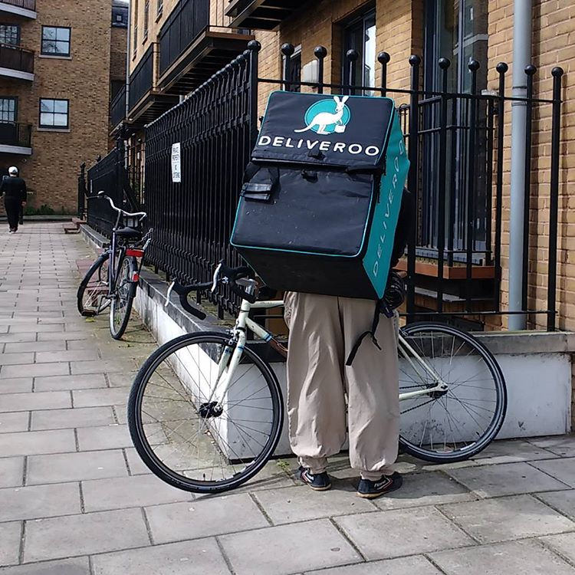

- Watch a video about how cycle couriers in Madrid and Paris are turning technology against the big platforms. Take notes on what is said about:
a the problems of working for big companies like Deliveroo.
b why the couriers started La Pájara Ciclomensajería (The Delivery Bird).
c what Alex in Paris is doing.
d the advantages of working for a co-op.
e the problems the co-ops face.

3a Match the verbs with the words they go with.
1 spend a your own company
2 support b the money equally
3 set up c society going
4 share d an ageing population
5 cut out e half your monthly income on rent
6 keep f the middle man

3b Now do the same.
7 build f with the big companies
8 compete g peanuts
9 give h huge profits for the shareholders
10 pay i a stake in the company
11 make j a strong client base
12 own k workers more autonomy

3c Check your answers with a partner.
Discuss how the collocations above might be connected to the video you watched.

4 Read the Fact File below. Then work in pairs and discuss these questions.
a Which facts surprise you? Why?
b Is there anything you don’t find surprising? Why?
c How do you think your country compares in terms of these facts and figures?

- There are over 17,000 co-operatives in the UK – owned by 17 million individual members.
- Co-operatives contribute £38 billion a year to the British economy.
- Modern co-operatives started with the Rochdale Pioneers in the north of England in 1844.
- The most famous co-operative is the Co-Op, which is best known for its supermarkets and funeral care brands, and has over 8 million members.
- There are large-scale housing co-ops, credit unions, farms and hotel chains.
- There are also many examples of community-owned pubs, shops, and so on.
- Barcelona FC, one of the most famous teams in the world, is run as a co-operative.
- The number of people involved in co-operatives is growing dramatically. Last year, around 700,000 new members joined a co-op.

5 Work in groups. Think about the job you do – or about areas you have worked in
in the past. Discuss:
- whether you know of any co-operatives working in those areas
- how easy it’d be to set up a co-operative in your field
- what difficulties you’d face if you did so

ANSWER KEY & TEACHER’S NOTES

As a lead-in, you could ask the class to look at the photo and ask the whole group if anyone ever orders from Deliveroo or other similar companies, why, and what they use them for. You could also ask if anyone has ever worked for a company like this – or knows anyone who has. How was it?

Exercise 1
Put students in small groups of 3 or 4. Tell them to read the questions in exercise 1 and to ask if there’s anything they’re not sure of. The words in italics are common collocations / chunks.

Once students are sure they understand the questions, let them discuss them in groups. Monitor and help out with new language, where necessary. You may want to get some better versions of things students are trying to say up on the board so you can come back to this as part of your round-up. It’s always good to gap the odd word here and there and then see if you can elicit the missing words from the group. You can include the first letter of the missing words if you want to make it easier. For example:

One good thing is you get to choose the h……….. you work. (hours)
- Yeah, but on the other hand, the m………..’s usually pretty bad. (money)

One other way to round up might simply be to ask the whole group for their ideas on the pros and cons of working for the big platform companies. You could write some of these ideas up on the board – using whole sentences, to show students better ways of saying what they’re trying to say.

Exercise 2
Here’s the video link: https://www.youtube.com/watch?v=I0Z5PBgwu60

It’s taken from Novara Media, a new left-leaning independent media source that you might want to mention.

Tell students they’re going to watch a video and give them a minute or two to read a-e so they know what to take notes on. Tell them the video is in Spanish and French, as well as English, but has subtitles throughout.

Play the video. Give students a few minutes to compare their notes / answers in pairs.
Then round up by getting ideas from the whole group.

Answers:
a There are no employment rights. There’s no sick pay or holiday pay. Sometimes people get attacked while delivering things. Cycle couriers have to pay for their own bikes and pay to keep them in good condition. They’re not even insured by the firms.
b They all used to work for big platform companies and got fed up. They were sick of being exploited. They wanted more autonomy and a fairer way of splitting the money earned.
c He’s a web designer and he’s basically copying the apps that the big platforms use and making them open-source and free for co-ops. He created the Coop cycle software.
d The advantages are you have a stake in the company, you have greater autonomy, you get better working conditions and better contracts, better coverage in terms of insurance and social security . . . and you’re part of a global network of like-minded people.
e They’re starting from scratch, so they have to build up their client base and persuade people to switch to them.

Exercise 3a-3c
It’s probably best to explain the task to students and tell them to try both Exercise 3a and 3b in one go.

When it looks like most students have finished, put them in pairs / groups and ask them to compare their answers and discuss how they think the collocations could connect to the video they watched.

The elicit answers from the class as a whole.

3a

1e 2d 3a 4b 5f 6c

Things are increasingly hard for millennials today. Rents are rising much faster than wages are, and on average, people spend half their monthly income on rent. The young are also having to support an ageing population, so fewer and fewer people are having to do more and more work.

One solution to do is to set up your own company and run it as a co-operative, so you share the money equally between all members. Having your own app allows you to cut out the middle man – the platform.

Cycle couriers basically helped keep society going during lockdown.

3b

7j 8f 9k 10g 11h 12i

It takes time for start-ups to build a strong client base, but once they do, they can start to compete with the big companies. Co-operatives give workers more autonomy and control over their work. Everyone owns a stake in the company, so they all have something invested in making it a success.

The big firms pay peanuts – very low wages – because the main goal isn’t looking after their workers, it’s making profits for shareholders.

Exercise 4
Explain the task. Give students a few minutes to read through the Fact File and to ask about anything they’re not sure of. You could then tell the class about anything that surprised you in the fact file before putting them in groups to discuss what they read.

Again, monitor and help out with new language, where necessary. You may want to get some better versions of things students are trying to say up on the board so you can come back to this as part of your round-up. Gap words here and there and then see if you can elicit the missing words from the group. Include the first letter of the missing words if you want to make it easier.

Exercise 5
This is an add-on if you have time left at the end of the class. It’d designed to help students think about possible positive changes they could get involved in themselves in the future. Run it as above.

